Collaboration: I worked alone

1. Create a LARGE_PROPERTY table with the structure shown in Figure 6-29. (Hint: If you have trouble creating the primary key, see Figure 3-36 in Module 3.)

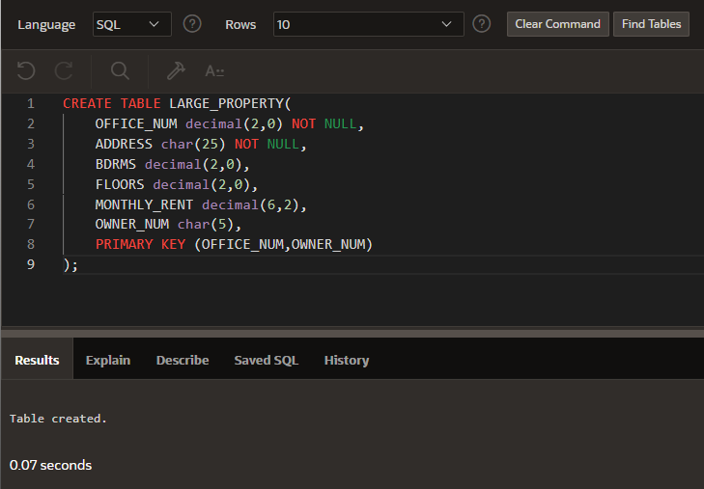

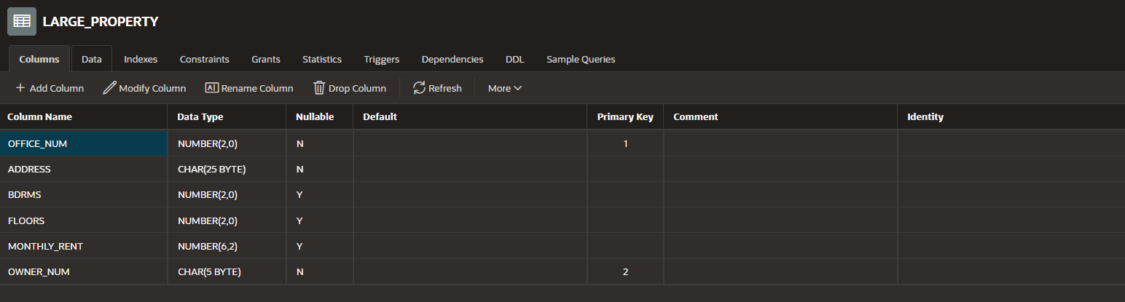

2. Insert into the LARGE_PROPERTY table the office number, address, bedrooms, monthly rent, and owner number for those properties whose square footage is greater than 1,500 square feet.

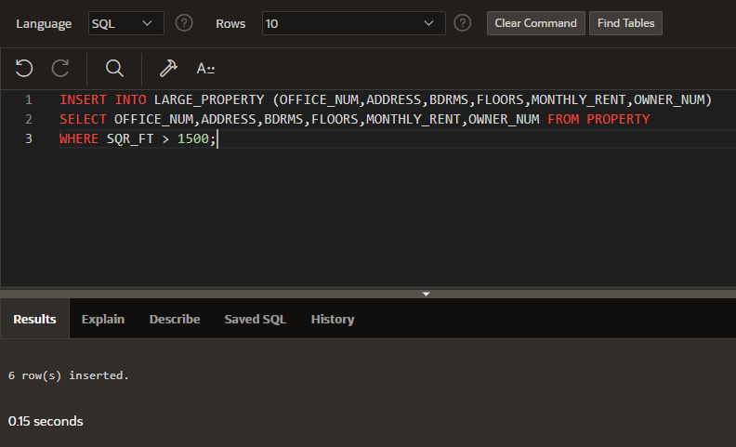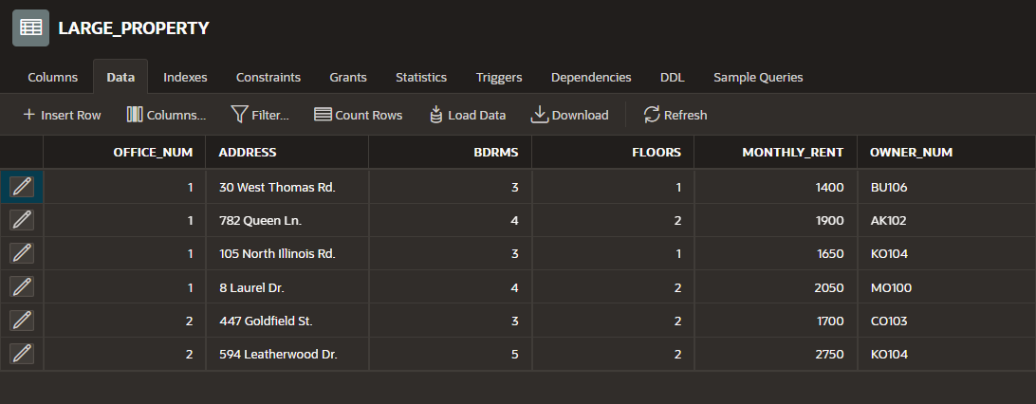

3. StayWell has increased the monthly rent of each large property by $150. Update the monthly rents in the LARGE_PROPERTY table accordingly.

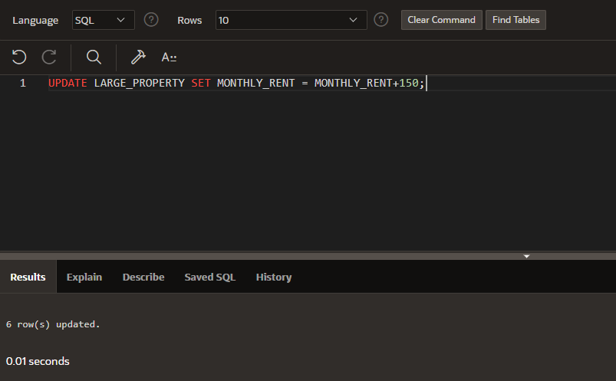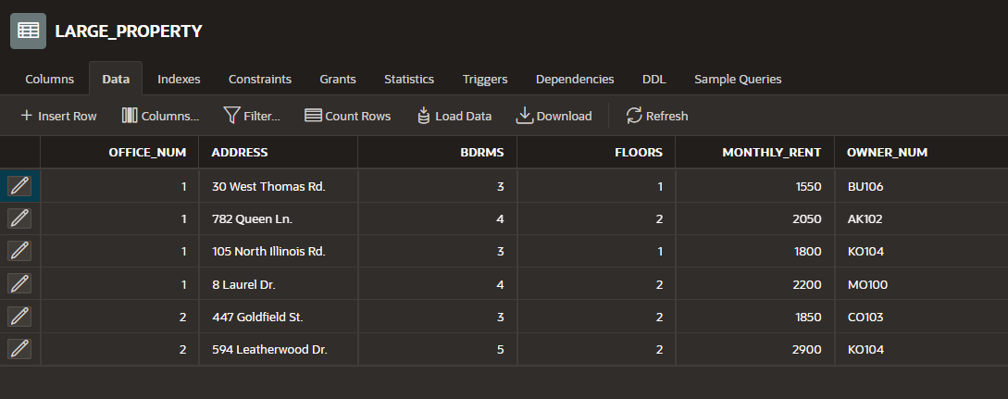

4. After increasing the monthly rent of each large property by $150 (Exercise 3), StayWell decides to decrease the monthly rent of any property whose monthly fee is more than $1750 by 1 percent. Update the monthly rents in the LARGE_PROPERTY table accordingly.

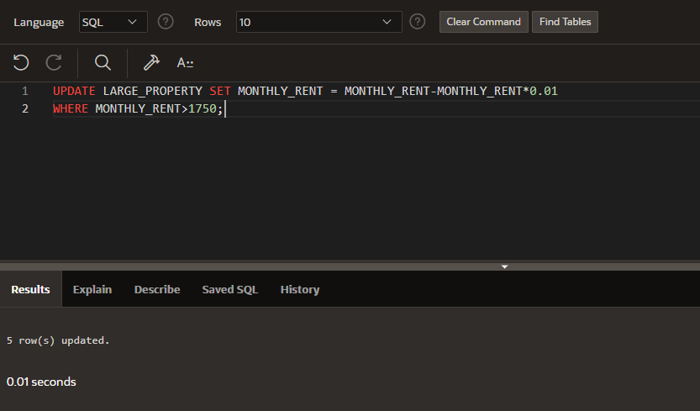

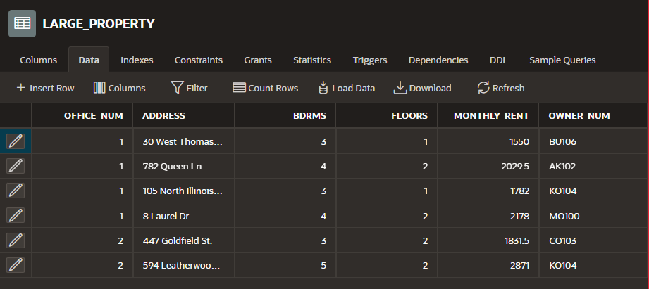

5. Insert a row into the LARGE_PROPERTY table for a new property. The office number is 1, the address is 2643 Lugsi Dr, the number of bedrooms is 3, the number of floors is 2, the monthly rent is $775, and the owner number is MA111.

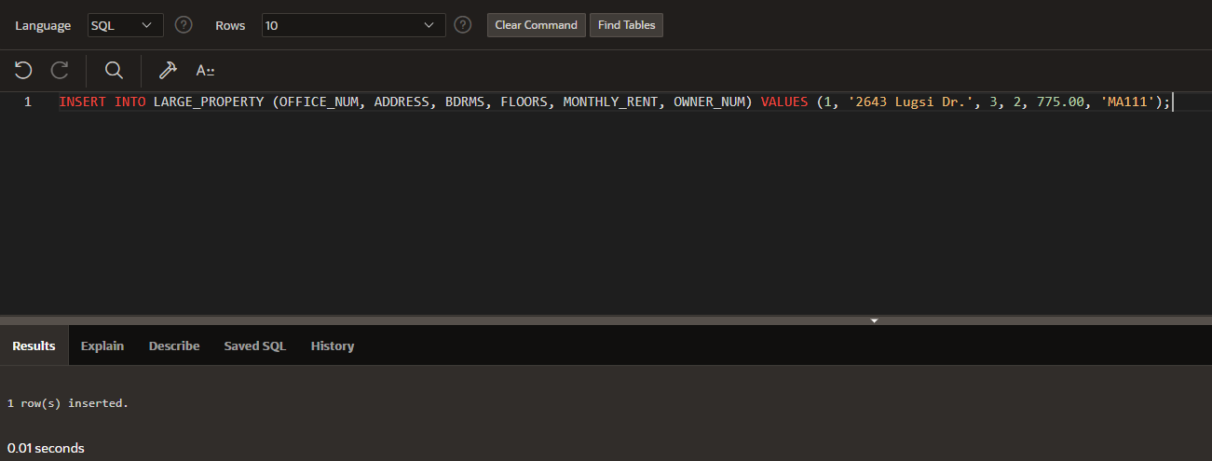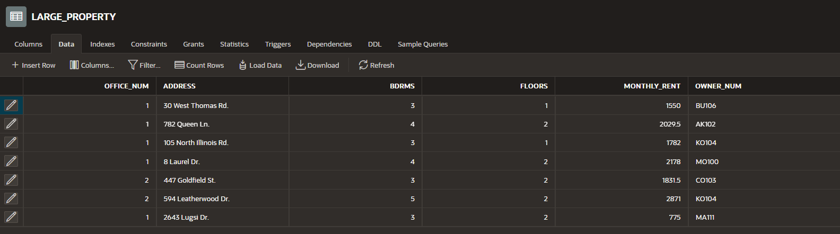

6. Delete all properties in the LARGE_PROPERTY table for which the owner number is BI109. (I’m going to assume this is a typo and wanted me to delete BU106)

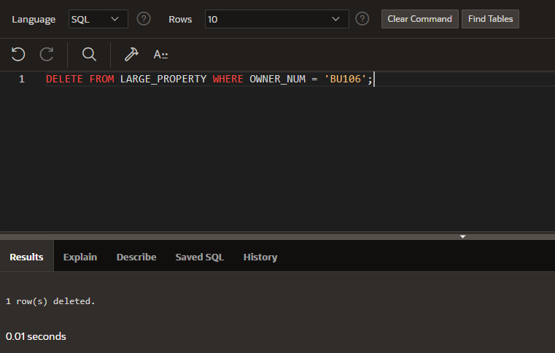

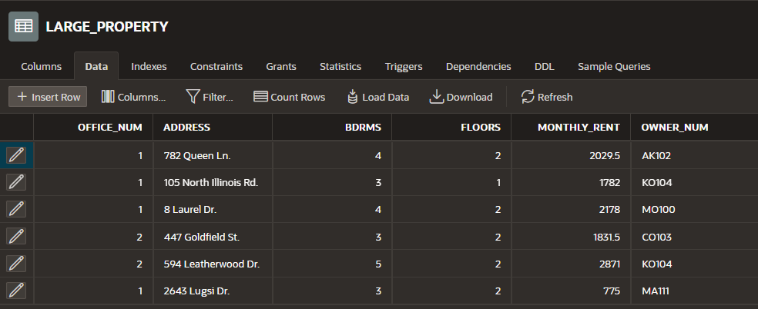

7. The property in managed by Columbia City with the address 105 North Illinois Rd is in the process of being remodeled and the number of bedrooms is unknown. Change the bedrooms value in the LARGE_PROPERTY table to null.

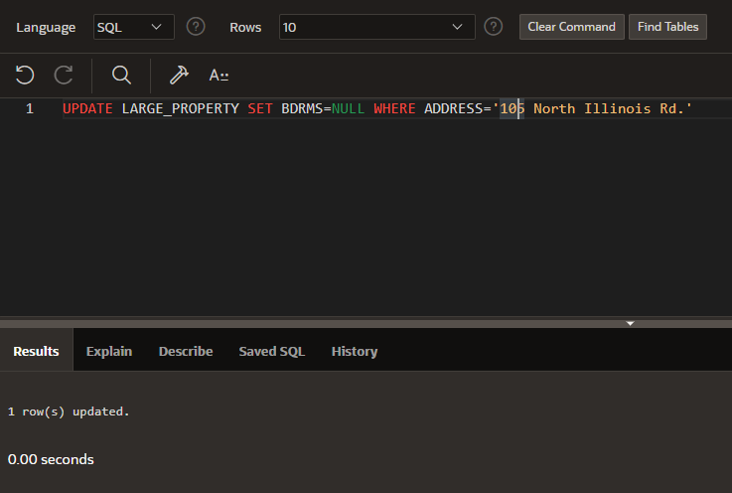

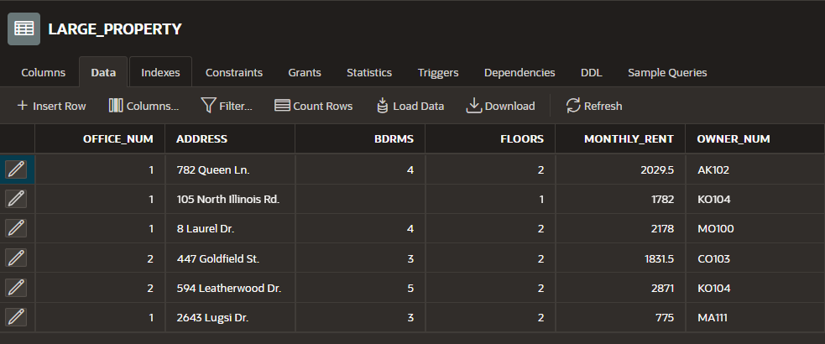

8. Add to the LARGE_PROPERTY table a new character column named OCCUPIED that is one character in length. (This column indicates whether the property is currently occupied.) Set the value for the OCCUPIED column on all rows to Y.

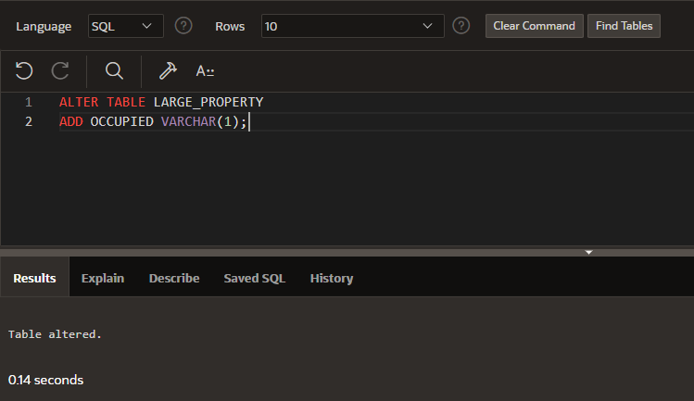

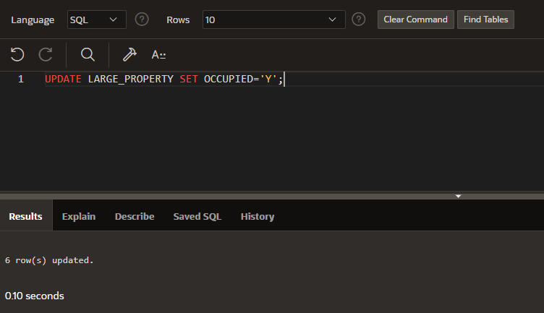

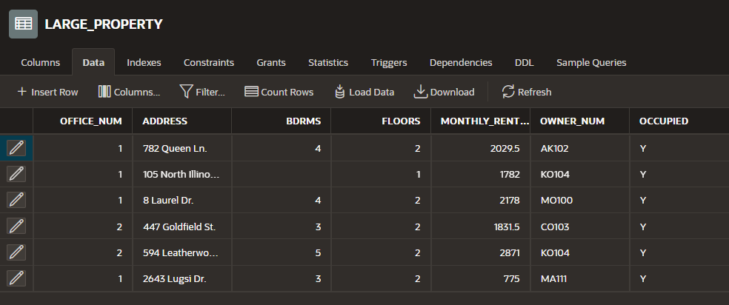

9. Change the OCCUPIED column in the LARGE_PROPERTY table to N for office 9.

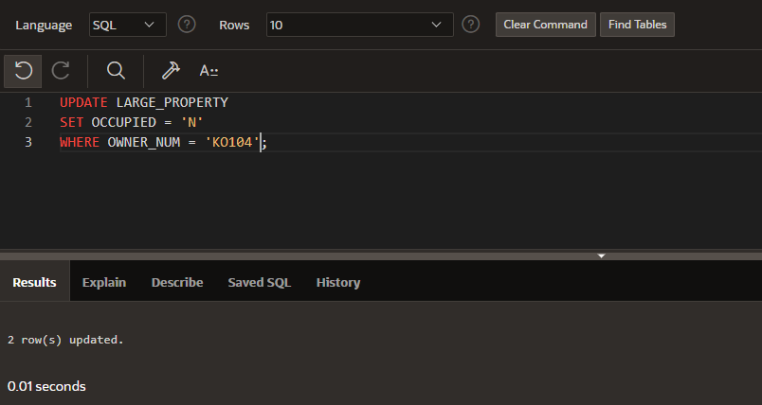

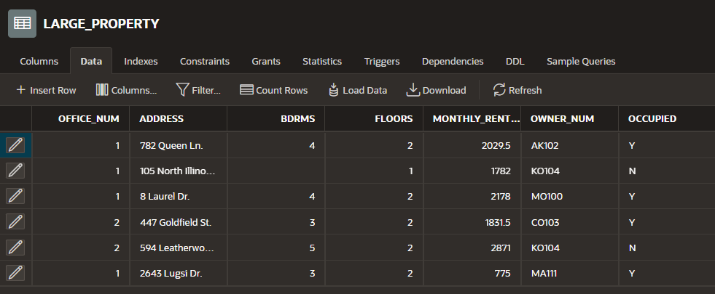

10. Change the MONTHLY_RENT column in the LARGE_PROPERTY table to reject nulls.

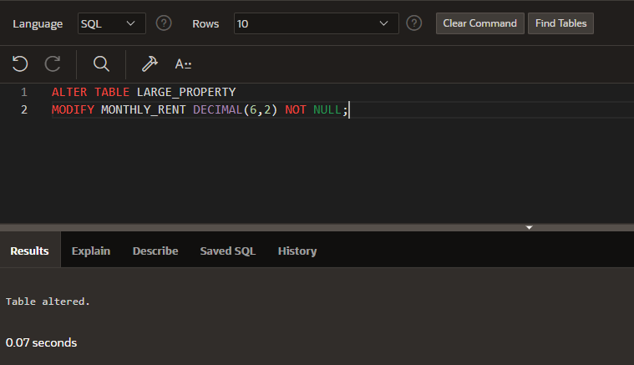

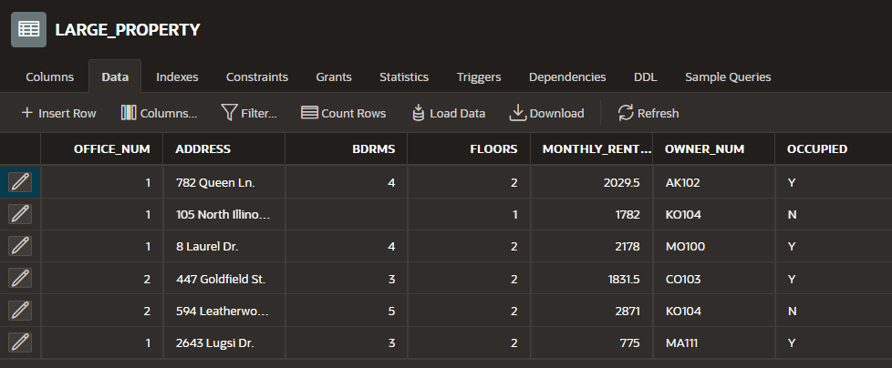

11. Delete the LARGE_PROPERTY table from the database.

